Our continued fossil fuel use has now led to the first obvious signs of global warming: 2 years of large wildfires, ocean acidification, crop reductions in Eastern Washington, and intense rain when it does fall.

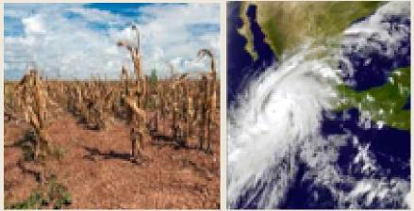

Faith & secular communities must   
bond together and with people of   
developing countries who will   
suffer most from climate change.   
We must forge ties with future   
generations, who deserve a healthy   
planet. We must make mending   
and sharing our Earth our   
common cause.

PRESERVE OUR   
PLANET WITH ACTS OF   
COURAGE,   
INTELLIGENCE

& LOVE

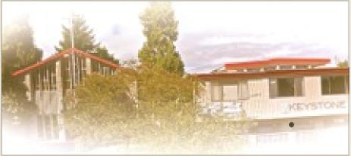

KEYSTONE U C C CHURCH

5019 Keystone Place North   
Seattle, WA 98103

"As an open and affirming Christian   
community, committed to social justice   
and care of our planet, we pledge to   
take actions to increase our   
understanding and stewardship of   
God's good earth. To live out our call to   
be a force for environmental justice, we   
will advocate for national and   
international policies that enable a   
swift transition from fossil fuels to safe   
renewable energy and for economic

systems that are fair. We will carefully   
consider how our actions individually   
and as a congregation can lead to a   
more sustainable world."

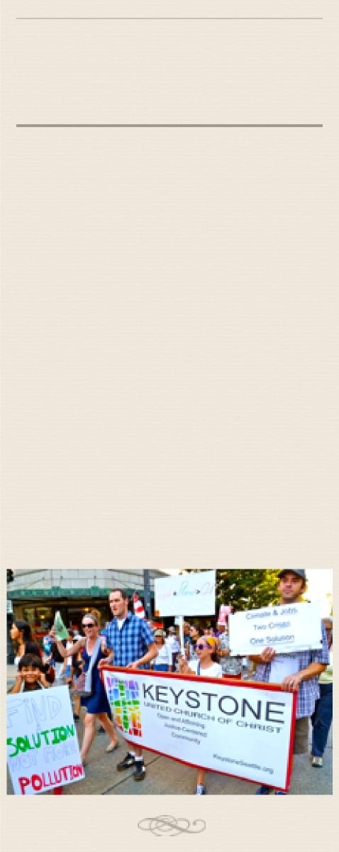

KEYSTONE UCC

GREEN TEAM

Global Warming is a challenge   
so large and complex that   
individual actions seem to make   
no difference. But these actions   
give direction, clear conscience,   
and strengthen impetus for   
other actions. When a   
community acts, it makes the   
seeming impossible, turn   
inevitable.

Eat carbon friendly: more vegetarian, more local, less palm oil.

Calculate your carbon footprint. Reduce it 10% per year.

Cut your transportation carbon footprint. Walk, Bike, Bus, Train, Hybrid or Electric Car.

Back local clean energy.

Champion public funding for safer walking, cycling & public transportation.

Support energy efficiency of public buildings.

Promote local green groups like EarthMinistry, Sightline, GotGreen ...

Be brave, inspire family, friends and acquaintances to act on climate change.

Be active in green groups like 350, Greenpeace, Sierra Club, Citizens Climate Lobby .

Pressure politicians to act on climate change and work to replace those that won't.

PERSONAL SUSTAINABILITY SET AN EXAMPLE...WALK THE TALK:

Live more simply; buy less stuff reduce, reuse, recycle.



CARBON REMAINING WORLDWIDE

1.2 Trillion Metric Tons

MAKE A CLIMATE DIFFERENCE

EVERY DAY

[KeystoneSeattle.org](http://KeystoneSeattle.org) (link to Environmental Resources at bottom)

CARBON SPENT SINCE 1870

2.0 Trillion Metric Tons

Source: InsideClimate News

**97%** of climate scientists say we must act immediately and decisively to cut our carbon emissions, to avoid out-of-   
control climate chaos within our   
children’s lifetimes. We have the   
solutions at hand to slow global   
warming and to pass on a safer future   
for our children: promote clean   
energy (wind, solar, wave, tidal), price   
carbon pollution, cut fossil fuel   
subsidies, increase energy efficiency of   
buildings & transportation & cut   
deforestation. We just need to fight   
misinformation and to pressure our legislators to act on climate change.

*Reduce Your Carbon Footprint*

COMMUNITY SUSTAINABILITY:

*Support Public Transportation*

ADVOCACY:

Learn about climate change; correct misinformation.

*Advocate for Clean Energy like Wind & Solar*